**Practical – 4: Application of Decision Tree and SVM1) Decision Tree**

**Description:** Our main task on iris dataset is to create an iris (name of a flower) classifier based on a given properties that are the sepal and petal size.

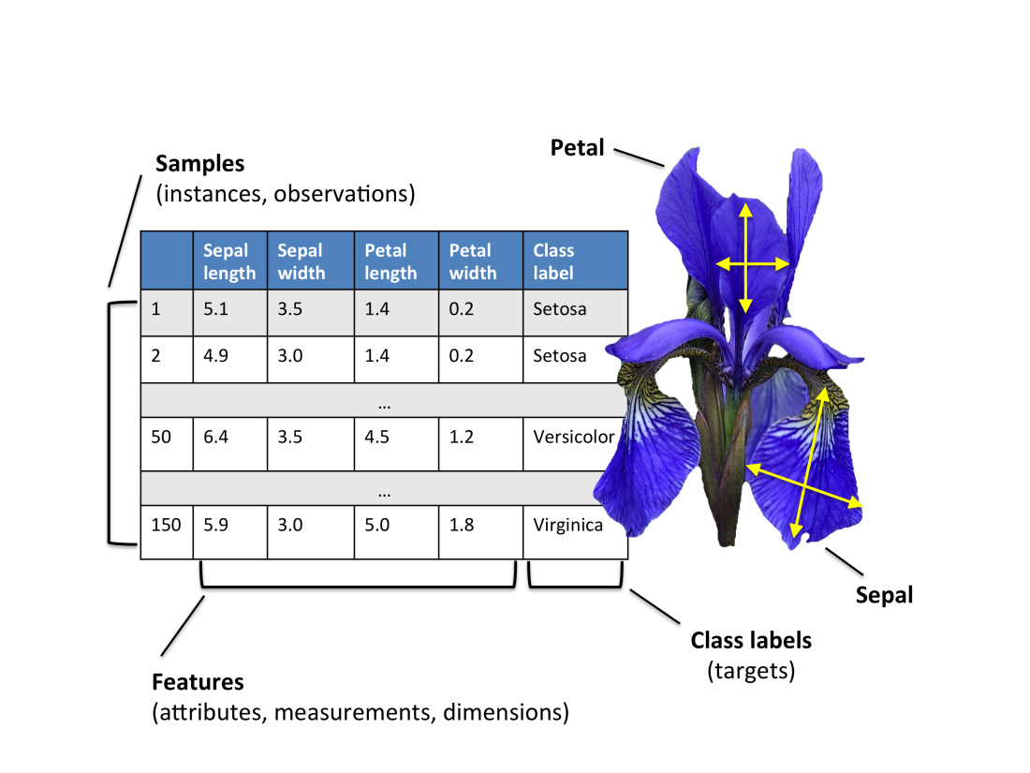

**Code:**

**# Importing Libraries**

import pandas as pd

from sklearn.datasets import load_iris

from sklearn.tree import DecisionTreeClassifier

from sklearn.tree import export_graphviz

**# Load data and store it into pandas DataFrame objects**

iris = load_iris()

X = pd.DataFrame(iris.data[:, :], columns = iris.feature_names[:])

y = pd.DataFrame(iris.target, columns =["Species"])

**# Defining and fitting a DecisionTreeClassifier instance**

tree = DecisionTreeClassifier(max_depth = 2)

tree.fit(X,y)

**# Visualize Decision Tree**

from sklearn.tree import export_graphviz

**# Creates dot file named tree.dot**

export_graphviz(

tree,

out_file = "myTreeName.dot",

feature_names = list(X.columns),

class_names = iris.target_names,

filled = True,

rounded = True)

**# Making a Prediction On a New Sample**

sample_one_pred = int(tree.predict([[5, 5, 1, 3]]))

sample_two_pred = int(tree.predict([[5, 5, 2.6, 1.5]]))

print(f"The first sample most likely belongs a {iris.target_names[sample_one_pred]} flower.")

print(f"The second sample most likely belongs a {iris.target_names[sample_two_pred]} flower.")

**Output:**

The first sample most likely belongs a setosa flower.

The second sample most likely belongs a versicolor flower.

